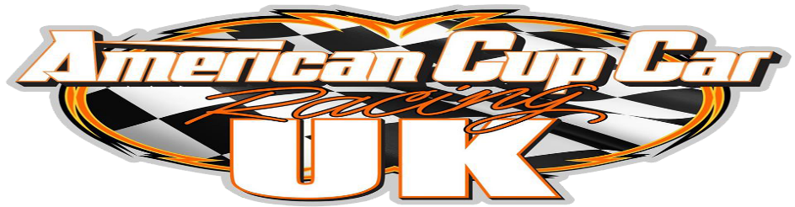
Please fully complete this licence/contract application form and send it back together with your Incarace contract to ACC Racing Ltd
27 Holloway Lane, St George’s, Redditch, Worc’s, B98 7ET
2023 Senior & Junior Licence Application
Please ensure your payment is enclosed (payable to American Cup Car Racing Ltd) and 3 x photos are enclosed also.

THIS AGREEMENT is made between American Cup Car Racing Ltd after referred to as ACCR,

(FULL) NAME
Race # _ Address

Date of birth if underage of 16 / _/______
Original Birth Certificate If under the age of 16 enclosed YES/NO
I fully understand the nature and type of racing in which I wish to participate and the circuit’s nature, lay out and geography, and may inspect any circuit prior to racing thereon. I am satisfied that all such raceways are safe for me to race upon and that if I have at any time any doubts as to their safety, I am entitled to decline to race and inform the ACCR Director of the reasons.
I also acknowledge that any ACCR Directors or Officials and drivers are in no way to be held responsible for any accident or injury or loss of any kind, including fatalities to myself or any of my parties accompanying me at any sanctioned event. I agree not to take any legal action / litigation or to direct any persons to pursue such actions against any persons involved with ACC racing Ltd promoted events. I agree that it is my responsibility to insure myself and my equipment or any other party accompanying me against such circumstances, and I will take out the necessary cover through private insurance to cover any event as I feel necessary.
By signing this Contract I agree that I have read and understood and will at all times abide by all rules and regulations set out in the rule book and it is my responsibility to ensure I have a copy of these, and I agree to pay any fines or any invoices for parts and serve any bans issued by ACC Racing Ltd as per the regulations, I also agree not to break any copy rights Trade Marks of any of the parts, cars or associating equipment or name rights involved with ACC Racing and I agree to promote and support any sponsors associated with ACC racing, including displaying the required names, logos, and decals upon my car as required, and agree to remove any personal sponsors from the car if not approved by ACC Racing Ltd..
I agree that I will be held responsible for any person that accompanies me to any meeting or event, including their conduct, I will ensure that their conduct is in line with the ACCR rule book and that they are aware of this.
By signing into this contract, I understand that it’s binding and covered by UK laws.
This contract also includes the terms and conditions as set out in the INCARACE Contract and Senior ACCR & Junior ACCR rules and regulations 2023 and the ORCI / Track rules and regulations 2023.

Signed Driver ______________________________________________Dated ____/____/____
Fees for 2022 licence including your Incarace fee £125.00 (£75.00 if Incarace Licence applied for separate)
BACs – Account American Cup Car Racing Ltd – sort - 30-96-97 account - 24994060

All forms to be returned to the above address, Enclosed with payment and 3 x passport photos

